**Day 6**

1.      Categorize products by stock status

(Display product_name, a new column stock_status whose values are based on below condition

 units_in_stock = 0  is 'Out of Stock' ;  units_in_stock < 20  is 'Low Stock')

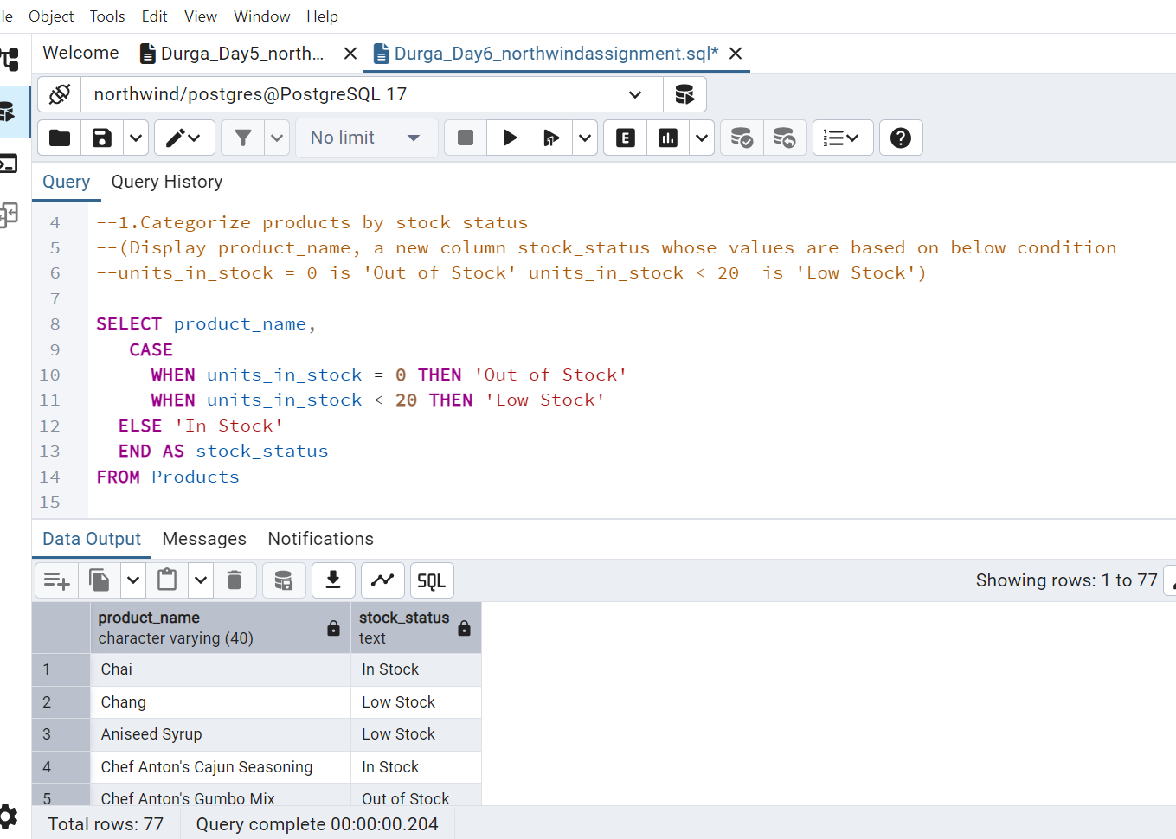

2.      Find All Products in Beverages Category

(Subquery, Display product_name,unitprice)

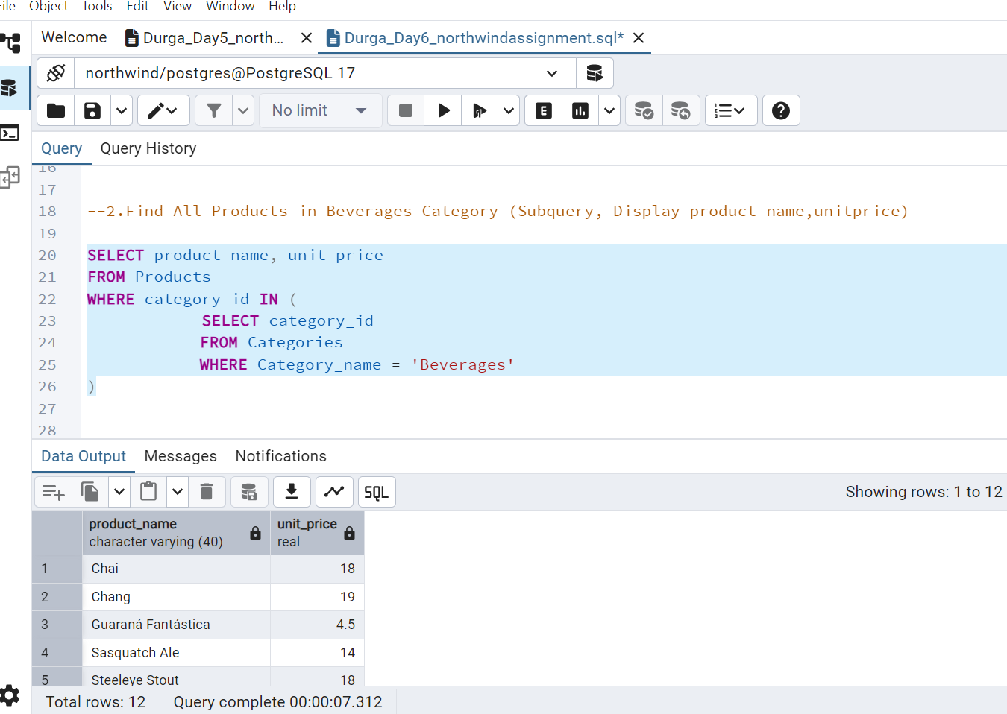

3.      Find Orders by Employee with Most Sales

(Display order_id,   order_date,  freight, employee_id.

Employee with Most Sales=Get the total no.of of orders for each employee then order by DESC and limit 1. Use Subquery)

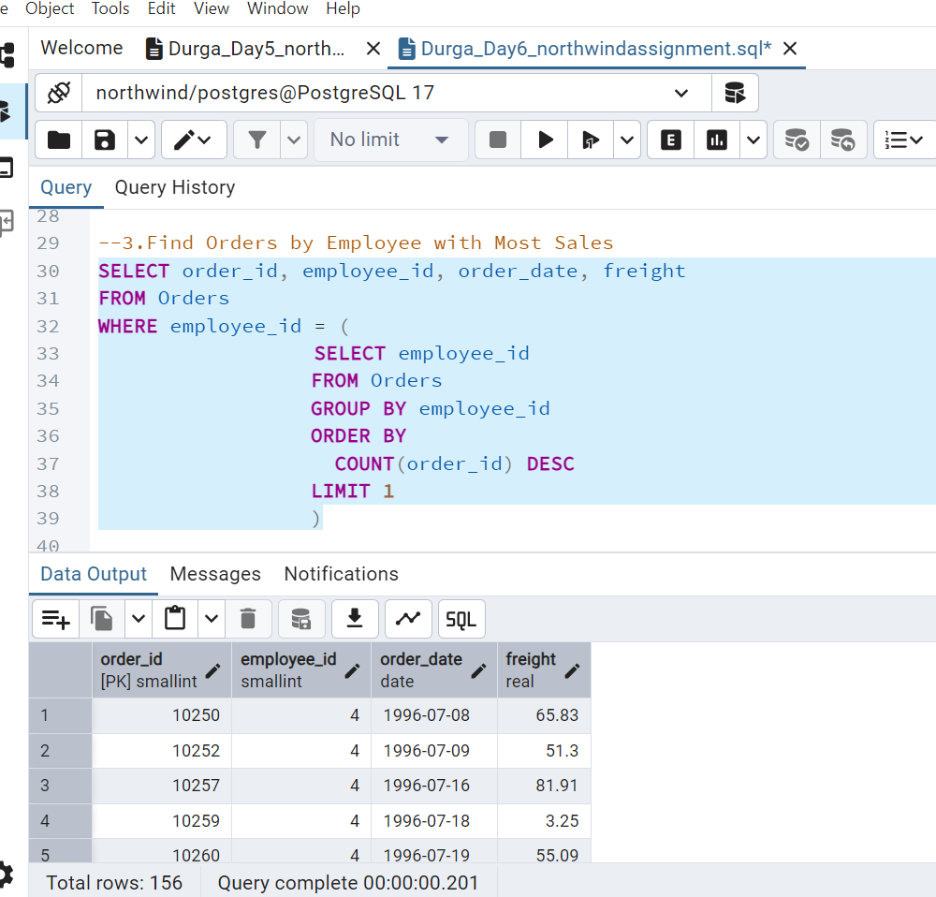

4.      Find orders  where for country!= ‘USA’ with freight costs higher than any order from USA. (Subquery, Try with ANY, ALL operators)

Using ANY Operator

Any operator – Condition is true If freight costs is at least greater than any one of the USA freight costs (Subquery part) i.e Any freight cost above the minimum USA freight cost.

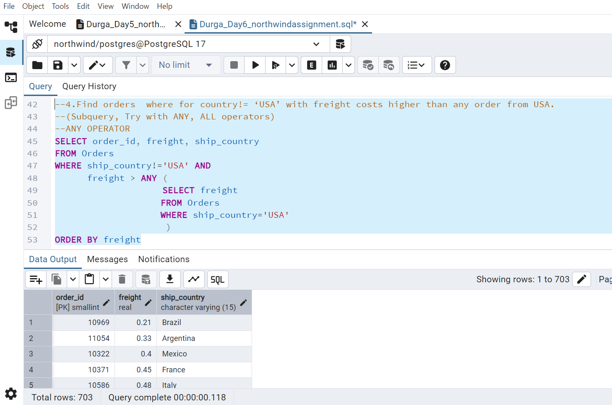

Using ALL Operator

ALL Operator – Conditon is true only if freight cost exceeds every USA freight costs

i.e freight cost greater than the maximum USA freight cost

